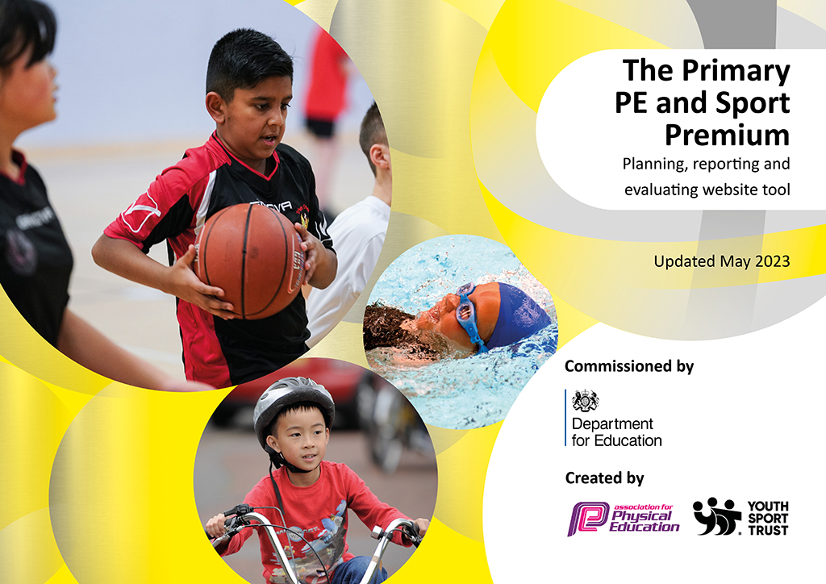
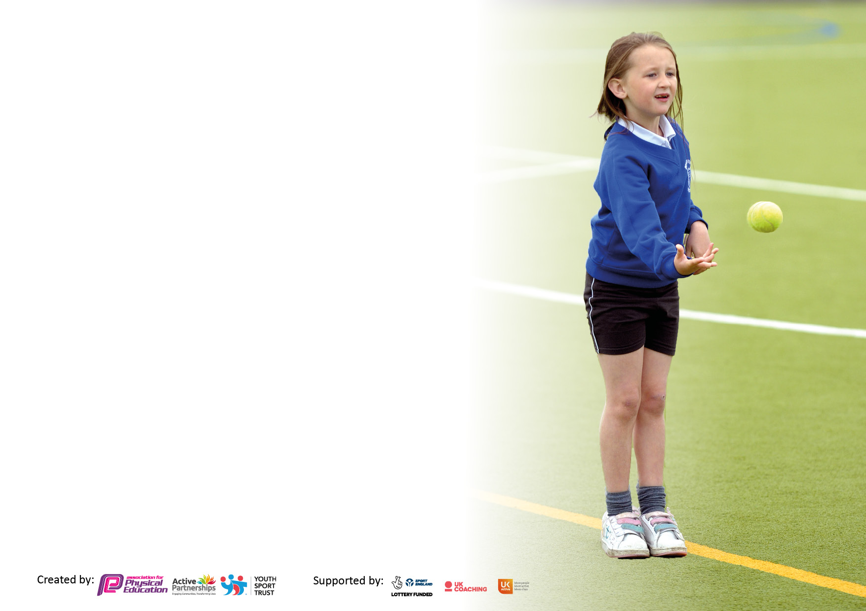

It is important that your grant is used effectively and based on school need. The Education Inspection Framework makes clear there will be a focus on ‘whether leaders and those responsible for governors all understand their respective roles and perform these in a way that enhances the effectiveness of the school’.

Under the Quality of Education Ofsted inspectors consider:
Intent - Curriculum design, coverage and appropriateness
Implementation - Curriculum delivery, Teaching (pedagogy) and Assessment
Impact - Attainment and progress

To assist schools with common transferable language this template has been developed to utilise the same three headings which should make your plans easily transferable between working documents.

Schools must use the funding to make additional and sustainable improvements to the quality of Physical Education, School Sport and Physical Activity (PESSPA) they offer. This means that you should use the Primary PE and sport premium to:

- Develop or add to the PESSPA activities that your school already offer
- Build capacity and capability within the school to ensure that improvements made now will benefit pupils joining the school in future years
- The Primary PE and sport premium should not be used to fund capital spend projects; the school’s budget should fund these.

Please visit gov.uk for the revised DfE guidance including the 5 key indicators across which schools should demonstrate an improvement. This document will help you to review your provision and to report your spend. DfE encourages schools to use this template as an effective way of meeting the reporting requirements of the Primary PE and Sport Premium.

We recommend you start by reflecting on the impact of current provision and reviewing the previous spend.

Schools are required to publish details of how they spend this funding, including any under-spend from 2021/2022, as well as on the impact it has on pupils’ PE and sport participation and attainment. All funding must be spent by 31st July 2023.

We recommend regularly updating the table and publishing it on your website throughout the year. This evidences your ongoing self-evaluation of how you are using the funding to secure maximum, sustainable impact. Final copy must be posted on your website by the end of the academic year and no later than the 31st July 2023. To see an example of how to complete the table please click HERE.

Details with regard to funding
Please complete the table below.

Total amount carried over from 2021/22 | N/A
Total amount allocated for 2021/22 | £ £20,540.00
How much (if any) do you intend to carry over from this total fund into 2022/23? | £ 0
Total amount allocated for 2022/23 | £ 20,510.00
Total amount of funding for 2022/23. To be spent and reported on by 31st July 2023. | £ 20,510.00

Swimming Data
Please report on your Swimming Data below.

Meeting national curriculum requirements for swimming and water safety.

N.B. Complete this section to your best ability. For example you might have practised safe self-rescue techniques on dry land which you can then transfer to the pool when school swimming restarts.
Due to exceptional circumstances priority should be given to ensuring that pupils can perform safe self-rescue even if they do not fully meet the first two requirements of the NC programme of study
What percentage of your current Year 6 cohort swim competently, confidently and proficiently over a distance of at least 25 metres?  N.B. Even though your pupils may swim in another year please report on their attainment on leaving primary school at the end of the summer term 2022. Please see note above | 51.6%
What percentage of your current Year 6 cohort use a range of strokes effectively [for example, front crawl, backstroke and breaststroke]? Please see note above | 17.3%
What percentage of your current Year 6 cohort perform safe self-rescue in different water-based situations? | 53.1%
Schools can choose to use the Primary PE and sport premium to provide additional provision for swimming but this must be for activity over and above the national curriculum requirements. Have you used it in this way? | No

Action Plan and Budget Tracking
Capture your intended annual spend against the 5 key indicators. Clarify the success criteria and evidence of impact that you intend to measure to evaluate for pupils today and for the future.

Academic Year: 2022/23 | Total fund allocated: | Date Updated:
Key indicator 1: Increased confidence, knowledge and skills of all staff in teaching PE and sport |  |  |  | Percentage of total allocation:
 |  |  |  | %
Intent | Implementation |  | Impact
Your school focus should be clear what you want the pupils to know and be able to do and about  what they need to learn and to  consolidate through practice: | Make sure your actions to achieve are linked to your intentions: | Funding allocated: | Evidence of impact: what do pupils now know and what can they now do? What has changed? | Sustainability and suggested next steps:
Promote a whole school approach to PE and School Sport -providing all staff with professional development, mentoring, appropriate training and resources to help them teach PE and sport more effectively to all pupils, and embed physical activity across your school  CPD for staff | PP & LE (PE co-ordinator) have taken part in local PE Subject Leader meetings. The PE Co-ordinator shared the learnings with all colleagues during staff meetings.  PE surveys sent out to assess teachers’ confidence in teaching PE.  Implement a new PE Scheme -Get Set For PE  The PE co-ordinator took part in the Leicestershire and Rutland PE Conference, taking part in a variety of workshops including a OFSTED deep dive workshop, physical literacy and How to make an active school. The PE Co-ordinator shared the learning points with all staff.  Half termly data updates from teaching staff and LE.  Pupil survey for extracurricular clubs  Level 5 in Primary School PE Specialist course. LE to start in September 24 | SLSSP Membership  Get Set For PE  £550  Cones £58  Yoga Mats  £289.80  SLSSP Membership  £800 | All our teaching staff said they enjoyed teaching PE and were confident to do so. Gymnastics/Dance came out as the least confident.  From results, a new PE scheme was bought Get Set For PE. Much clearer planning for staff. From conversations with staff, they feel much more equipped to teach good quality, progressive lessons. LE feels children are making much more progress and challenged more.  New equipment has been resourced/bought to ensure PE lessons can go ahead as planned.  PP disseminated information re Physical Literacy to staff. Staff understand the term physical literacy more now and how it underpins life with PESSPA.  All teachers assess half termly using GS4P. 74.6% girls in KS2 are working at and 4.8% working beyond. In comparison there are 62.3% boys ks2 working at and 21.5% working beyond their age-related expectations.  A large number of children voted for clubs of non-traditional sports like skateboarding, boxing, karate, table tennis to be offered. LE looking into getting external coaches in to support this.  Impact unknown but impact on improved teaching/better knowledge. This can be disseminated to staff. | SLT will continue to champion the PE co-ordinator role. The PE co-ordinator will deliver whole school staff workshops. The PE Co-ordinator will also survey staff to highlight areas of PE where further CPD is needed.  Awaiting results of EOY survey for impact of GS4P.  Drop in’s on PE lessons.  To include active brain breaks across the school next year.  To increase girls in KS2 working beyond.
Key indicator 2: The engagement of all pupils in regular physical activity – Chief Medical Officers guidelines recommend that primary school pupils undertake at least 30 minutes of physical activity a day in school |  |  |  | Percentage of total allocation:
 |  |  |  | %
Intent | Implementation |  | Impact
Your school focus should be clear what you want the pupils to know and be able to do and about  what they need to learn and to  consolidate through practice: | Make sure your actions to achieve are linked to your intentions: | Funding allocated: | Evidence of impact: what do pupils now know and what can they now do? What has changed? | Sustainability and suggested next steps:
Providing targeted activities or support to involve and encourage the least active.  1.Increase the number of KS2 playground leaders to develop greater provision.  2. Ensure SEN are included in leadership training where appropriate for individual children  3. Give ownership and opportunity to plan and organise playground activities and clubs.  4. Listen to pupil’s voice and adapt opportunities as appropriate  5. Children who are less able physically or less confident so do not participate in physical activity to have a support through a targeted intervention group  Inspire ALL students to get involved in 30 minutes of physical activity during school time and take part in physical activity outside of school. | 1.Year 5 children have had playground leader training with JR from LSLSSP on 28th September 2023.  1. Four year 6 children have been trained as Sports Ambassadors to help support inter-competitions and pupil voice.  2. All SEN children are given the same opportunities to participate in the playground leader training but none chose to participate.  3. Year 5 playground leaders are then given ownership to design activities for lunchtime. Y4 ‘yellow bibs’ are in the FS/Y1 children to help support with lunchtimes  3. Sports ambassadors lead virtual competitions and games during lunch.  4. Regular meetings with the sport ambassadors/playground leaders.  4. Feedback forms from competitions/events for children  4. Children asked what activities they would like to have as lunch time/after school clubs.  5. The school took part in the SLSSP Big Moves project designed for Foundation stage and KS1 pupils who lack fundamental movement skills/physical literacy. A coach from SLSSP (APP) deliver 6 sessions to 15 targeted pupils, the pupils undergo a fundamental movement assessment on week 1 and 6 to evaluate the impact of the intervention. A member of staff (LE/MF) supervised the sessions and also delivered the sessions on Wednesday and attended a Big Moves training course. Additional TA (MF) supports on LE days.  The school participated in the Energise Club. The 10 weeks of sessions delivered by SLSSP staff with inactive/less confident y5/6 female pupils. The sessions occurred 3x a week (mon, weds, fri) delivered by a SLSSLP coach (APP) and a member of staff.  The school took part in an Inclusive Sport Club targeting SEND pupils. A coach from SLSSP delivered a 6 week club alongside a member of staff. The coach delivered  The whole school took part in the Move It March project. Each child was given a physical activity tracker to fill out during March 2023. Certificates and prizes were awarded to children who achieve physical activity milestones (250 active minutes=Bronze, 500 active minutes=Silver, 750 active minutes=Gold and 1000 active minutes=Platinum). Pupils were also given points for achieving milestones and the most active class won a trophy.  Holiday clubs run throughout Oct, Feb, Easter, May and Summer holidays. These are sports clubs held by LE | £2700 to South Leicestershire SSP Membership fee.  SLSSP Membership  SLSSP Membership  SLSSP Membership  SLSSP Membership  SLSSP Membership | - Playground leaders have been providing equipment and delivering games at break and lunchtimes. They have been provided with set activities from our PE scheme Get Set 4 PE. This has allowed lunchtimes to be more active through having structured activities occurring.  Sports Ambassadors lead our internal and virtual competitions for KS1 and KS2 children. As a result, children can get involved with and be exposed to competitive sport.  - The responsibility given to year 4 means they are better prepared to when they are in Y5 and become playground leaders.  - Children given the opportunity to voice their views/opinions which means the engagement is higher  - After completing the Initial Assessment, 50% of students scored less than 5 in Week  1 of the Project, therefore not meeting the requirements to pass the Assessment. However, on week 6, 60% of children were able to do 5 or more movements and  meeting the requirement to pass the Assessment. This is an improvement of 10%  compared to week 1.  Y5/6 exposed to a variety of different sports. From this, a couple of the girls wanted to join the school’s girls football team. Some of the other girls developed confidence to join a school netball club.  Some of the girls have now got the confidence to join netball/football clubs.  All Children participated in Move it March and 150/450 children demonstrated that they were moving more than 15mins a day. As a school we received 1337 points. 5BL were the most active class and received a trophy. | We provide staff to supervise all of the targeted physical activity projects delivered by SLSSP. As a result, the staff feel confident and competent in delivering the programmes, therefore the projects can be embedded in school and are sustained throughout the year.  To ensure there is a PE Rep on the school council to ensure pupil voice across the whole school.  Carry out pupil interviews to hear a wider pupil voice and adapt provision based on feedback.  Continue to participate in targeted intervention groups from the LSLSSP.  Begin to use ‘Active families’ from Get Set 4 PE to encourage more activity at home for targeted families.  To use sports apprentice to develop target lunchtime activity groups and to support playground leaders.  Create longevity to Move it March and Active travel month

Key indicator 3: The profile of PESSPA being raised across the school as a tool for whole school improvement |  |  |  | Percentage of total allocation:
 |  |  |  | %
Intent | Implementation |  | Impact
Your school focus should be clear | Make sure your actions to | Funding | Evidence of impact: what do | Sustainability and suggested
what you want the pupils to know | achieve are linked to your | allocated: | pupils now know and what | next steps:
and be able to do and about | intentions: |  | can they now do? What has
what they need to learn and to |  |  | changed?
consolidate through practice:
To engage student voice and use student leaders to raise the profile of PE and School Sport.  Encourage active travel to school.  Embedding Physical Activity and Well-being into the school day  To increase the number of staff who are active to raise the profile of sport and exercise in school. | The school trained 4 students to become Sports Ambassadors to promote physical activity. The ambassadors formed a school sport organising crew and devised action plan to promote PE and physical activity in school.  Sporting achievements were also celebrated sport in assemblies. The school newsletter to contain information about physical activity, sports clubs and fixtures.  4 students were trained to become Well-being Ambassadors to support mental health and internet safety in school. The Well-being Ambassadors have been supporting the Sports Ambassadors.  Pupil survey for extra-curricular clubs  The school took part in an Active Travel Month. During October 2022, students and families were encouraged to walk to school. A trophy was given to the class that actively travelled the most.  Student playground leaders trained to make lunch times more active. JR from SLSSP delivered a Playground Leader workshop to 20 Year 5 students in Sept 2022  We have 4 Well-being ambassadors that have been on the training provided by the partnership.  We utilised the SLSSP Return to Well-being resources to support students back into school.  These included:  5 minute videos played during form time (registration). The focus was on mental health, dealing with anxiety, anger and bereavement and relaxation techniques.  Sent out wellbeing newsletters regarding -nutrition, sleep, physical activity, dental health  We have promoted SLSSP’s Staff Well-being Challenges to all staff. This included Marathon Month challenge. The challenge to place in October, staff had to travel 26.2 active miles during the month. Staff also took part in the Move It March challenge alongside students and a summer holiday activity challenge.  The SLSSP deliver Staff Well-being Ambassador training for 2 members of staff in school. The ambassadors took part in physical activity and mental health training. The ambassadors devised an action plan to support staff well-being. We were awarded £150 of funding to support our action plan.  Walks at lunch time set up for staff to attend. | Sports coach salary  £15,000  SLSSP Membership  SLSSP Membership  SLSSP Membership  SLSSP Membership  SLSSP Membership  SLSSP Membership | Sports ambassadors promote the competitions in assemblies, which has increased participation.  School sporting achievements celebrated in assemblies as well as external sporting achievements. Encouraging other children to get involved in sports.  A large number of children voted for clubs of non-traditional sports like skateboarding, boxing, karate, table tennis to be offered. LE looking into getting external coaches in to support this.  Back in October the whole school participated in active travel month 2022. This was the first year the children recorded it on Dojo. The children loved coming in, in the morning and marking how they came to school. A lot of self-motivation 4BS was the most active class. 257 children participated and 31.2% of children actively travelled for 11days of more during October.  We have set up the initiative of Park and Stride, encouraging parents to use The Grange Carpark. We have followed this up with National clean air day too.  They have put on assemblies for KS1 and KS2 highlighting the importance of wellbeing. Two key assemblies were for World Mental Health Day and one about digital well-being  We run a mindfulness after school club which has helped calm busy minds of children. Next year we hope to get outside. | The school continues to train and give opportunities to the Sports Ambassadors. Sports Ambassadors will be trained next year to ensure student voice in represented in the school’s physical activity offer.  Sports ambassadors to have more of a profile around school.  A member of the school council will become a sports rep, to ensure pupils voice/feedback can be heard at school council meetings.  School is employing a Sports Apprentice to help raise PESSPA throughout the school during break, lunch and after school. They will help support playground leaders, intra-school competitions and support the ‘yellow bibs’ to for KS1.  Rewards for active travel to school throughout the whole year. To work with Eco-council.  The school continues to promote active travel through school newsletters and social media. The school works closely with the Leicestershire County Council Officer to promote Active Travel including encouraging parents to park and stride.  TB to run gardening club next academic year. Get well-being ambassadors involved with gardening club.  Mindfulness club at lunchtimes.  The lunch time supervisors are trained to put on a range of activities/games. The lunchtime supervisors have created zones to ensure a variety of activities can take place during lunch times. The Playground Leaders will continue to put on a lunch time clubs for KS1 children.  Yoga to potentially be offered to staff after school.
Key indicator 4: Broader experience of a range of sports and activities offered to all pupils |  |  |  | Percentage of total allocation:
Intent | Implementation |  | Impact
Your school focus should be clear | Make sure your actions to | Funding | Evidence of impact: what do | Sustainability and suggested
what you want the pupils to know | achieve are linked to your | allocated: | pupils now know and what | next steps:
and be able to do and about | intentions: |  | can they now do? What has
what they need to learn and to |  |  | changed?:
consolidate through practice:
Additional achievements:  Provide all pupils with a broad and balanced PE curriculum and school sport offer, which includes alternatives to traditional sport. | A range of activities was offered to targeted groups through SLSSP membership (as outlined in Key Indicator 1).  Taster session for tri-golf.  Tag Rugby sessions provided by Leicester Tigers through Beehive.  Our KS1 pupils took part in a multi-skills festival designed to develop physical literacy and a range fundamental movement skills.  Rice bowl football tournament for next year  Pupil survey to collate ideas for pre/after school club.  The school sent out the SLSSP Christmas physical activity resources to all parents, it was designed to keep children and families active over the Christmas holiday. We also sent out the SLSSP resources design to keep children active and healthy over the Easter and Summer holiday.  Also, we promoted the SLSSP parent portal which contains information about local walking routes and fun physical activity videos. | SLSSP Membership  SLSSP Membership  £10  SLSSP Membership | Big Moves had a positive impact with a 10% improvement.  Energise group saw an increase in school sport participation.  Children enjoyed but too expensive to implement.  Tried to start up a rugby club after the sessions but there was poor uptake.  The school did enter a tag rugby competition.  Children will have training sessions to train for the tournament. Children get to be become part of a team sport and all the benefits that go with it -social, emotional, personal.  Gave a boost to those who attended. Provided staff members greater picture of what physical literacy is and how best to support specific pupils with fundamental movement.  Pupils selected from a list or provided ideas of school sports they would like to see offered. Yet to know the impact of uptake. | To start in Autumn2 and continue this throughout the year to have maximum impact.  To continue the SLSSP intervention groups throughout the year with either LE or OB

Key indicator 5: Increased participation in competitive sport |  |  |  | Percentage of total allocation:
 |  |  |  | %
Intent | Implementation |  | Impact
Your school focus should be clear | Make sure your actions to | Funding | Evidence of impact: what do | Sustainability and suggested
what you want the pupils to know | achieve are linked to your | allocated: | pupils now know and what | next steps:
and be able to do and about | intentions: |  | can they now do? What has
what they need to learn and to |  |  | changed?
consolidate through practice:
Increasing and actively encouraging pupils’ participation in the school competition. Ensuring competition is for all and not just ‘sporty’ children. | Subscription to SL SSP provides opportunities for high ability, lower ability, SEND, less active and Pupil Premium pupils. We participated in sports festivals to aid transition to secondary schools.  Pupils took part in INSPIRE festivals which are designed to engage targeted pupil and inspire them to be involved in physical activity.  Big Moves  Energise  Inclusive club  Move it March  Active Travel  Pupils also took part in DEVELOP festivals and competitions, which are designed to develop physical literacy and sport specific skills  Girls football festival  Sports Ability Festival  Tag Rugby Festival  Tennis Festival  Year 6 Rounders festival  Pupils took part in EXCEL competitions which are designed for our most able pupils and are based on performance.  Cross Country  Girls Football Danone Cup  Football league  Table Tennis  Quicksticks Hockey  New Age Kurling  Gymnastics  Y5/6 Dodgeball  Y5/6 Basketball  Swimming Gala  Tennis  Pupils took part in the Quad Cup virtual competitions. The personal/team challenges were designed to give all students the opportunities to take part in a competition and learn sport specific skill/develop physical literacy.  The virtual competitions included:  Basketball  Running 5k | SLSSP Membership  SLSSP Membership  SLSSP Membership | Active Travel -257 children participated and 31.2% of children actively travelled for 11days of more during October.  Big Moves had a positive impact with a 10% improvement.  Energise group saw an increase in school sport participation.  All Children participated in Move it March and 150/450 children demonstrated that they were moving more than 15mins a day. As a school we received 1337 points. 5BL were the most active class and received a trophy.  In KS2, 60.5% of all the children have participated in competitions throughout the year. This is a variety or develop and excel competitions.  Pupils learn that sport has a competitive element but equally it gives a variety of other opportunities such as personal, social, emotional. Off the back of some of the develop festivals, some children now attend the Tennis club and girls football sessions outside of school.  Individuals choose if they want to participate during break/lunch times. | The school will continue to take part in competitions next academic year. SLSSP will promote a blended approach next year, both virtual and face to face competitions will take place. The SLSSP’s will develop a calendar of competitions/festivals designed to INSPIRE pupils, DEVELOP physical literacy and sports skill and enable students to EXCEL. The school is committed to taking part in the local competitions.  Improve competition % so more KS2 children participate.  To improve opportunities for KS1.  Sports ambassadors to run more virtual/intra competitions next year with OB.

Signed off by
Head Teacher: | Hayley Brown
Date: | 14/07/23
Subject Leader: | PF Pearce
Date: | 13.07.23
Governor: | Jill Bailey
Date: | 14.07.23

