FouTopic/Term | Autumn 1 - I am special and individual
Key Texts | 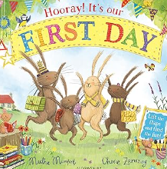  Hooray it’s your first day  By Martha Mumford | 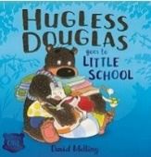  Hugless Douglas goes to Little School by David Melling | 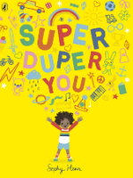  Super Duper You  by Sophy Henn | 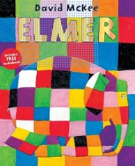  Emer By David Mckee | 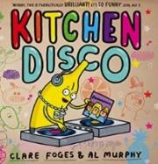  Kitchen Disco by Clare Foges |  | 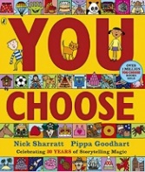  You Choose by Pippa Goodhart
Synopsis | 4 bunnies set off for their school adventure, can you help them to find the things that they need and get them to school on time? | . Hugless Douglas is a huggable brown bear who wakes up one morning in need of a hug. He goes to try and find one but none of them seem quite right. Join Douglas on his search for the perfect bear hug! | Sometimes we are loud, sometimes we are quiet, sometimes bold and clanky, sometimes soft and cuddly. Sophy Henn celebrates all the extraordinary and sometimes contradictory things we are in this joyful rhyming picture book | Elmer is not like other elephants, he is patchwork and likes to play tricks on the other elephants. | When the sun goes down, the Kitchen Disco starts up - and all the fruit in the fruit bowl come out to play. There are lemons who break-dance, tangerines who twirl and some very over-excited apples. Kitchen Disco is a zany and hilarious rhyming picture book. | The children will make a family tree (non-fiction) and share the differences in their families.  We will share these via tapestry and stick onto our wall with comments from the children. | Imagine you could go anywhere, meet anyone and do anything. Where would you live? Where would you sleep? Who would be your friends? What games would you play? Go on . . . you choose! With wonderfully detailed illustrations, Pippa Goodhart explores a whole range of scenarios where choosing is made fun!
Additional Texts | Starting preschool | 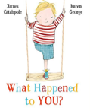 | 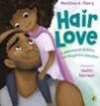 | 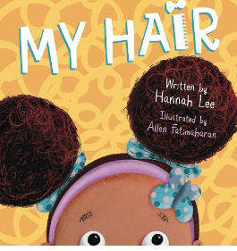 | 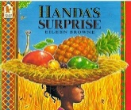  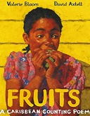 | 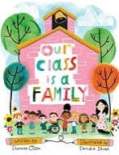 | 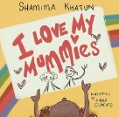  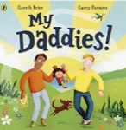
Themes/Outcomes | Transitions, getting to know each other. | Kindness. Emotions. | Individuality. Celebrating similarities and differences. Rhyming words. | Diverse families. Being different. | . Imagination. Making choices. Independence, fruit | Our surroundings and where we live and go to school. Community. | Being yourself.
Links | PSHE | PSHE | PSHE | Author links to Year 1 texts.  PSHE | Year 1 Spring Topic: House, home and our school and Geography Spring 2: Our School.  Year 2: villages, towns and cities. |  | PSHE

Topic/Term | Autumn 2 – Celebrations/Autumn
Key Texts | 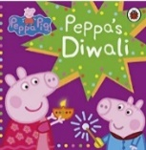 | 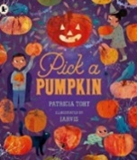  Pick a Pumpkin by Patricia Toht | 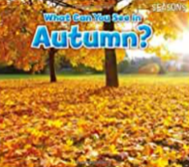  What can you see in Autumn by Sian Smith | 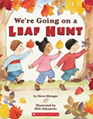  We’re Going on a Leaf Hunt by Steve Metzger | 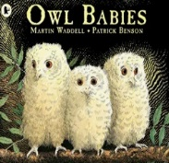  Owl Babies by Martin Waddell | 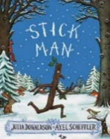  Stick Man by Julia Donaldson | 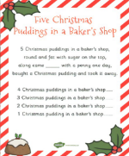  Poetry
Synopsis | Peppa and her family learn about Diwali at school. They learn all about festivities and traditions. | It’s Halloween! Which means it's time to dangle cobwebs and bats from the windows, put on costumes, and – most important of all – visit the pumpkin patch and scoop out the insides, carve a scary face, and finally light a candle inside, | In Autumn, children are taken on a tour of things they can see in autumn including typical autumn activities and changes in the natural world. Beautiful photos, very simple repeated text, high frequency and decodable words. | There are lots of beautiful Autumn leaves to find! Three friends have a big adventure hiking over a mountain and through a forest to collect leaves of all kinds and colours. What will they do with all their leaves at the end of the story? Rhyming text. | A tale of three baby owls, Sarah, Percy and Bill who wake up one night in their hole in a tree to find that their mother has gone. So, they sit on a branch and wait... Darkness gathers and the owls grow anxious, wondering when their mother will return. But, at last, she does and they bounce up and down with joy. | Stick Man lives in the family tree with his Stick Lady Love and their stick children three, but it's dangerous being a Stick Man. A dog wants to play with him, a swan builds her nest with him. He even ends up on a fire! Will he ever get back to the family tree in time for Christmas? Perhaps Santa can help... | - Christmas Pudding  - 5 Little Elves  - Twinkle, Twinkle Christmas Star  - Twinkle Twinkle Christmas Lights  - When Santa got Stuck up the Chimney
Additional texts | 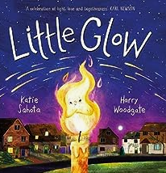 | 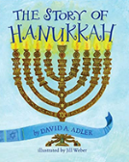  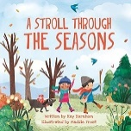 | 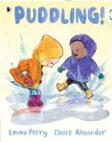  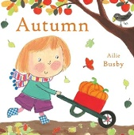 | 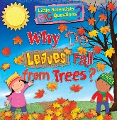 | 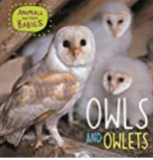  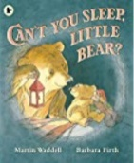 | 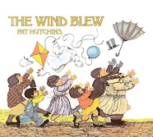 | 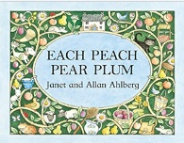
Themes/Outcomes | Celebrations throughout the year. | Halloween.  Hanukkah | Changing seasons. | Using our senses to oberve changes in seasons. | Owls, nocturnal animals. Being brave. Family. | Family. Santa. | Poetry and rhyming words.
Links | RE | FS Autumn key texts. | Year 1 Autumn science & geography. |  | Year 1 topic: Amazing animals and Autumn 2 topic: Autumn investigators (hibernation).

Topic/Term | Spring 1 – Winter/We Love Books (7 weeks)
Key Texts |   What can you see in Winter by Sian Smith |   Maisy’s Chinese New Year by Lucy Cousins | Little Rabbit Foo Foo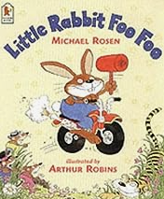  By Michael Rosen | Going on a bear hunt by Michael Rosen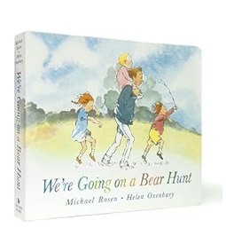 | 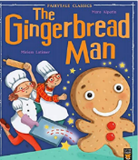  The Gingerbread Man by Mara Alperin | Shark in the Park  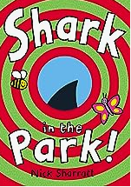  By Nicl Sharratt
Synopsis | Books in this series introduce emergent readers to the four seasons. In Winter, children are taken on a tour of things they can see in winter including typical winter activities and changes in the natural world. Beautiful photos, very simple repeated text, high frequency and decodable words and strong photo-to-text matching make this a perfect book for early readers to enjoy | Maisy is celebrating one of the world's biggest festivals: Chinese New Year! From hanging up lanterns to receiving lucky red packets and joining in the dragon dance at the parade, this bright and colourful storybook is a perfect introduction to the many joys of Chinese New Year. | The bully-boy bunny likes nothing better than to ride through the forest bopping everyone on the head. Wriggly worms, tigers, no one is safe. But here comes the Good Fairy – and she is not amused! | Follow and join in the family's excitement as they wade through the grass, splash through the river and squelch through the mud in search of a bear. What a surprise awaits them in the cave on the other side of the dark forest! | The cheeky little gingerbread man is having so much fun! He scurries away from Mr and Mrs Baker and all the hungry animals, but the he meets a crafty fox…Will the Gingerbread man meet a sticky end? | Timothy Pope has a brand new telescope and he's testing it out in the park. Peep through the die-cut holes in this book to see if you can spy a shark. Is that really a shark? Turn the page and find out
Additional texts | 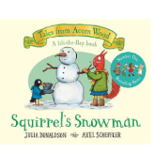  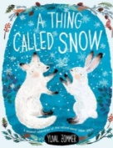 | 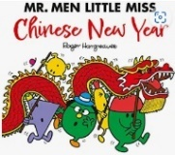 | 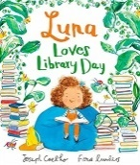   | 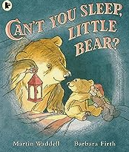 | 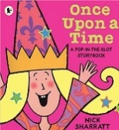 | 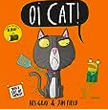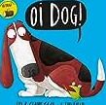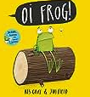
Themes/Outcomes | Changing seasons  Observing weather  Looking at ice | Chinese new year | Repeated refrains and joining with stories. | Repeated refrains and joining with stories. | Repeated refrains and joining with stories. | Rhyming patterns
Links |  |  |  | Year 1 Autumn Investigators topic. | Traditional tales in Y1
Topic/Term | Spring 1 – Spring/Growing
Key Texts | 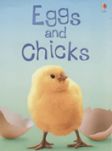  Eggs and Chicks by Fiona Patchett | 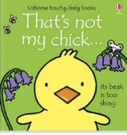  That’s not my Chick by Fiona Watt | 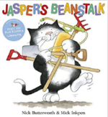  Jasper’s Beanstalk by Nick Butterworth | 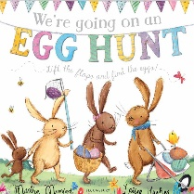 | 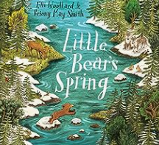  Little Bear’s Spring by Eli Woollard
Synopsis | Which bird lays the biggest egg in the world and how do tiny chicks learn to fly? Beginner readers can find answers to these questions and more in this colourful information book. Illustrated with fabulous photos and artwork. Easy-to-read text specially written with the help of a reading expert. Internet links to carefully selected websites with pictures, information and activities | Meet five adorable chicks in this delightful Easter addition to the much-loved That's not my... series. Babies and toddlers will love touching the textured patches as they meet chicks with soft wings, fuzzy tummies and rough feet. The bright pictures and textures to stroke are designed to help develop sensory and language awareness. | Jasper plants a bean. He waits for it to grow into a beanstalk all week. How long will he have to wait before he can start looking for giants? | Join the bunnies on a lift the flap easter story. | Little Bear has woken from a long winter sleep. But when he wakes the world around him is vast, white and silent.
Additional Texts | 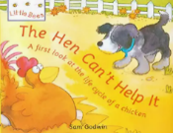  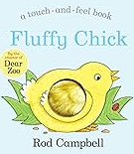 | 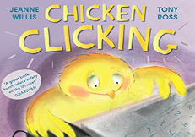 | 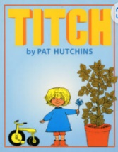 | 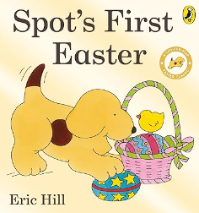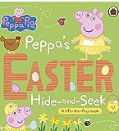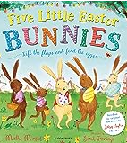 | 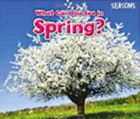
Themes/Outcomes | Growing and changes.  Lifecycles  Happy egg company: eggs in preschool. | Growing and changes.  Lifecycles | Growing seeds  Changes to a seed  Weather | Easter: RE | Changes to weather and seasons
Links | Year 1 science and geography: Seaons  Year 1: Growing caterpillars into butterflies. | Foundation Stage – Farm Animals | FS - Life cycles: Minibeasts Topic summer.2 | Links to FS: Easter  RE – Christian beliefs – Year 1 | Year 1 – Materials/plants Science  Whole School – Internet Safety  Y1: Hibernation and bears
Topic/Term | Spring 2 – Superheroes (People Who Help Us)
Key Texts/  Planning sequences | 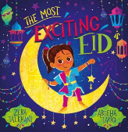  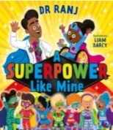  A Superpower like mine by Dr. Ranji Singh  The Most Exciting Eid |  | 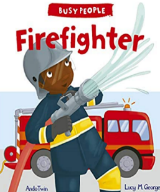  Firefighter by Lucy M George |  | 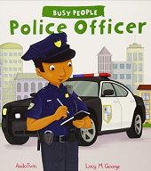  Police Officer by Lucy M George |  | 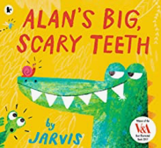 |  | 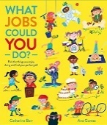 |  | 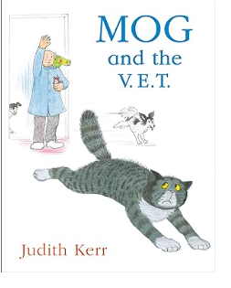
Synopsis | An empowering story about seeing the best in others and yourself, from Dr Ranj, bestselling author and the nation's favourite doctor. Femi has SUPERPOWERS! But not the superhero kind - she can't really fly or turn invisible. Femi's dad says she has lots of superpowers on the inside that make her special. From kindness to creativity, bravery to patience - join Femi as she discovers all the special powers that her, her friends, and the incredible people around her, bring out in one another every day. |  | Step inside the life of Frank the Fighter and discover the challenges he faces in his very busy job! Follow him and his crew from the moment the fire station alarm bell rings to his arrival at the emergency. |  | It’s a busy day at the festival for PC Seth and PC Thea. A car is stuck in the mud and a little boy needs their help. Can the officers solve every problem that comes their way? Discover what its really like to be a police officer and what the responsibilities of being in the police force are in this delightful picture book. A fun and fascinating first guide to an exciting profession, in the 'Busy People' series for young children. |  | Meet Alan the alligator, famed for his big, scary teeth. He sneaks into the jungle every day to scare the jungle animals ... But after a long day of scaring, Alan likes nothing better than to run a warm mud bath and take out his false teeth, which nobody knows about until his teeth go missing. What will Alan do now? |  | Pick your pefect job by doing something you love. Whether you want to make things, draw, write, be in charge, solve mysteries.  Explore a wide range of occupations from photographer, tree surgeon or surf coach through this interactive book. |  | Mog the cat is playing outside and hurts her paw. She will have to visit the vets, a place she does not like. Watch how she creates havoc when she is there.
Supporting Texts | 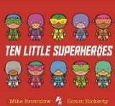  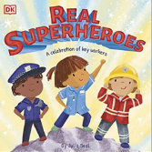 |  | 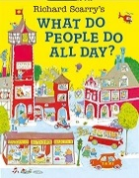 |  |  |  | 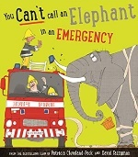 |  | 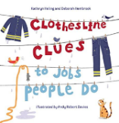 |  | 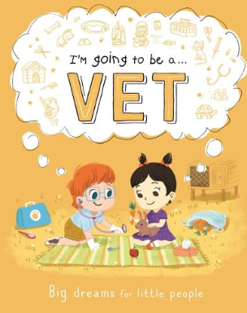
Themes | Eid  People who help us |  | People who help us  A visit from the fire service |  | People who help us |  | People who help us  Science: Teeth |  | People who help us  Different types of occupations  Looking at own family and their jobs. |  | People who help us  Pets
Links |  |  | Year 2 – fire and Light: Great fire of London (D.T- Fire engines) Year 1 and Year 5 Fire Service visit links. |  |  |  |  |  |  |  | Foundation Stage: farm animals
Topic/Term |  | Summer – By the Seaside/Transitions
Key Texts |  | 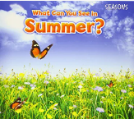  What Can You See in Summer? By Sian Smith |  | 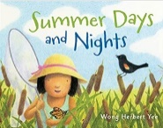  Summer days by Wong Herbert Yee |  | 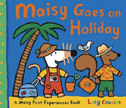  Maisie goes on Holiday by Lucy Cousins |  | 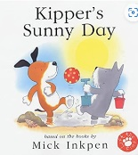  Kipper’s sunny day by Mick Inkpen |  | 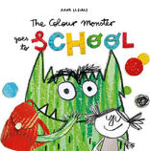  The Colour Monster goes to School by Anna Llenas
Synopsis |  | Books in this series introduce emergent readers to the four seasons. In Summer, children are taken on a tour of things they can see in summer including typical summer activities and changes in the natural world. Beautiful photos, very simple repeated text, high frequency and decodeable words and strong photo-to-text matching make this a perfect book for early readers to enjoy. |  | On a hot summer day, a little girl finds ways to entertain herself and stay cool. She catches a butterfly, sips lemonade, jumps in a pool, and goes on a picnic. At night, she sees an owl in a tree and a frog in a pond, and hears leaves rustling. Before long, she's fast asleep, dreaming about more summer days and summer nights. |  | In Maisy Goes on Holiday, Maisy enjoys packing her suitcase, meeting Cyril at a busy station and catching a train to the seaside. They have lots of fun on the beach and at the café, write postcards to their friends and finally sleep a peaceful night at their hotel (after bouncing on the beds, of course). Each of the First Experiences series describes a common first experience within Maisy's familiar and comforting world, offering a reassuring picture of something that might be new or less familiar. |  | Kipper loves sunny days, lift the flaps and find out what he does in the sun. |  | Follow The Colour Monster on a brand-new adventure, as he navigates his way through his first day at school! Anna Llenas's popular Colour Monster is back, and this time he's heading off to school! But what exactly is school? A spooky castle filled with terrifying animals? A place in the sky, amongst the rainbows and clouds? From music lessons, to lunchtime, to making new friends, the Colour Monster's first day of school is filled with exciting new adventures.
Supporting Texts |  |  |  |  |  | 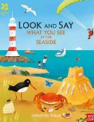  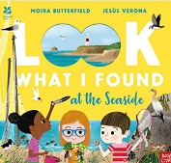 |  | 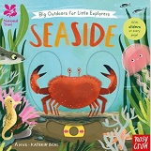  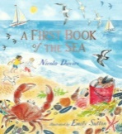 |  | 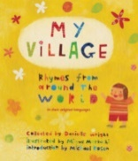
Themes |  | Season changes  Weather  Sun safety |  | Holiday, travel.  Season changes |  | Weather  The beach  Animals at the beach/under the sea |  | Sun safety  The beach  Animals at the beach/under the sea |  | Transition to school New starts  Meeting new teachers
Links |  | Year 1 – science: Seasons |  |  |  | Foundation Stage: Under the sea. |  | Foundation Stage: Under the sea. |  | Start of Pre-school – Hugless Douglas starts Little School  Reception – New Beginnings  PSHE

