FouTopic/Term | Autumn 1 - I am special and individual : 7 weeks
Key Texts | 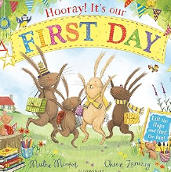  Hooray it’s your first day  By Martha Mumford | 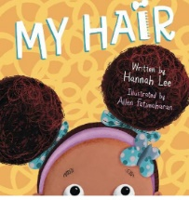  Everyones Welcome Text  By Hannah Lee. | 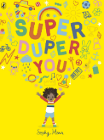  Super Duper You  by Sophy Henn | 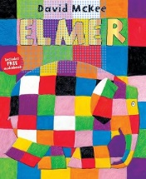  Elmer By David Mckee | 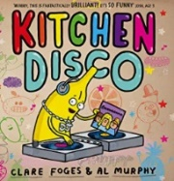  Kitchen Disco by Clare Foges | Everyones Welcome Text  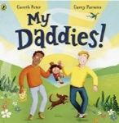  My Daddies by Garry Peters and Gary Parsons | 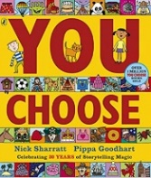  You Choose by Pippa Goodhart
Synopsis | 4 bunnies set off for their school adventure, can you help them to find the things that they need and et them to school on time? | A little girls quest for a hairstyle for her birthday. Will it be dreads or a fade out? A book celebrating differences in families. | Sometimes we are loud, sometimes we are quiet, sometimes bold and clanky, sometimes soft and cuddly. Sophy Henn celebrates all the extraordinary and sometimes contradictory things we are in this joyful rhyming picture book | Elmer is not like other elephants, he is patchwork and likes to play tricks on the other elephants. | When the sun goes down, the Kitchen Disco starts up - and all the fruit in the fruit bowl come out to play. There are lemons who break-dance, tangerines who twirl and some very over-excited apples. Kitchen Disco is a zany and hilarious rhyming picture book. | A book celebrating same-sex parents, introducing children to the different types of family in the world today. | Imagine you could go anywhere, meet anyone and do anything. Where would you live? Where would you sleep? Who would be your friends? What games would you play? Go on . . . you choose! With wonderfully detailed illustrations, Pippa Goodhart explores a whole range of scenarios where choosing is made fun!
Additional Texts | Starting preschool  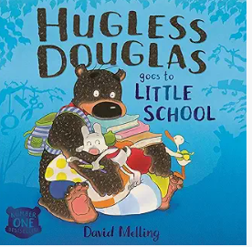 | 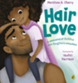 | 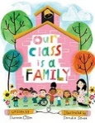 |  | 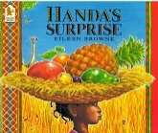 | 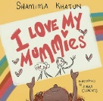  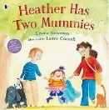
Themes/Outcomes | Transitions, getting to know each other. | Celebrating similarities and differences. Rhyming words  Diverse families.  Being different  Who is special to me? | I am special and unique. | Individuality. | Imagination. Making choices. Independence, fruit | Our surroundings and where we live and go to school.  Community.  Different types of families  The children will make a family tree (non-fiction) and share the differences in their families.  We will share these via tapestry and stick onto our wall with comments from the children. | Being yourself.
Links | PSHE | PSHE | PSHE | Author links to Year 1 texts.  PSHE | Year 1 Spring Topic: House, home and our school and Geography Spring 2: Our School.  Year 2: villages, towns and cities. |  | PSHE

Topic/Term | Autumn 2 – Celebrations/Autumn : 8 weeks
Key Texts | 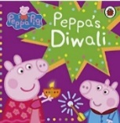 | 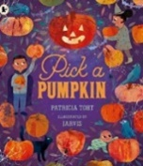  Pick a Pumpkin by Patricia Toht | 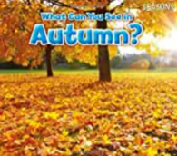  What can you see in Autumn by Sian Smith | 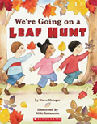  We’re Going on a Leaf Hunt by Steve Metzger | 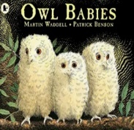  Owl Babies by Martin Waddell | 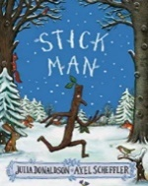  Stick Man by Julia Donaldson | 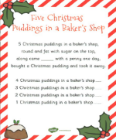  Poetry
Synopsis | Peppa and her family learn about Diwali at school. They learn all about festivities and traditions. | It’s Halloween! Which means it's time to dangle cobwebs and bats from the windows, put on costumes, and – most important of all – visit the pumpkin patch and scoop out the insides, carve a scary face, and finally light a candle inside, | In Autumn, children are taken on a tour of things they can see in autumn including typical autumn activities and changes in the natural world. Beautiful photos, very simple repeated text, high frequency and decodable words. | There are lots of beautiful Autumn leaves to find! Three friends have a big adventure hiking over a mountain and through a forest to collect leaves of all kinds and colours. What will they do with all their leaves at the end of the story? Rhyming text. | A tale of three baby owls, Sarah, Percy and Bill who wake up one night in their hole in a tree to find that their mother has gone. So, they sit on a branch and wait... Darkness gathers and the owls grow anxious, wondering when their mother will return. But, at last, she does and they bounce up and down with joy. | Stick Man lives in the family tree with his Stick Lady Love and their stick children three, but it's dangerous being a Stick Man. A dog wants to play with him, a swan builds her nest with him. He even ends up on a fire! Will he ever get back to the family tree in time for Christmas? Perhaps Santa can help... | - Christmas Pudding  - 5 Little Elves were busy one day  - Twinkle, Twinkle Christmas Star  - Twinkle Twinkle Christmas Lights  - I’m a Christmas fairy  - When Santa got Stuck up the Chimney
Additional texts | 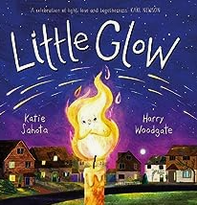  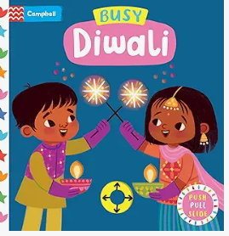   | 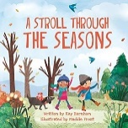  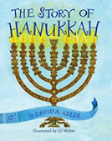  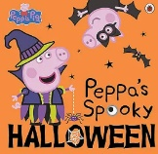  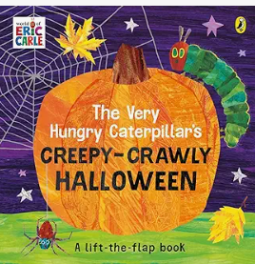 | 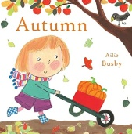  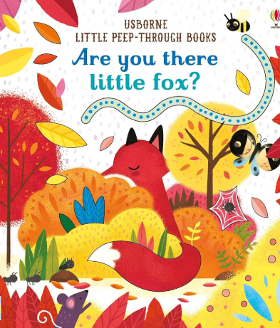 |  | 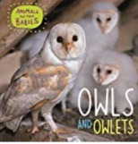  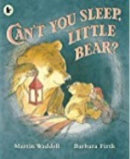 | 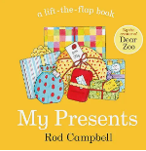  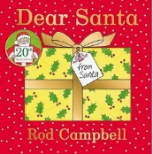  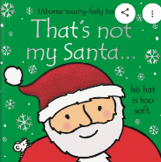  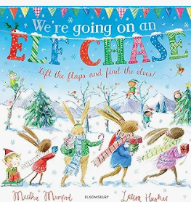
Themes/Outcomes | Celebrations throughout the year. | Halloween.  Hanukkah | Changing seasons. | Using our senses to oberve changes in seasons. | Owls, nocturnal animals. Being brave. Family. | Family. Santa. | Poetry and rhyming words.
Links | RE | FS Autumn key texts. | Year 1 Autumn science & geography. |  | Year 1 topic: Amazing animals and Autumn 2 topic: Autumn investigators (hibernation).

Topic/Term | Spring 1 – Winter/We Love Books 6 weeks
Key Texts | 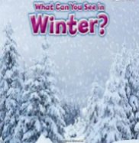  What can you see in Winter by Sian Smith | Squirrel’s Snowman  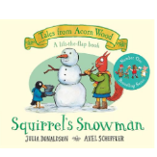  By Julia Donaldson | Shark in the Park / Shark in the snow  By Nick Sharratt  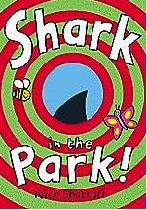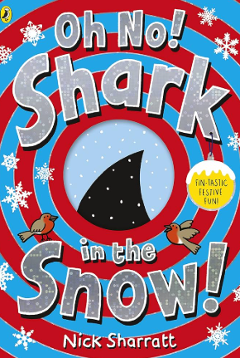 | Going on a bear hunt by Michael Rosen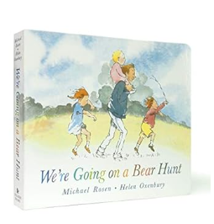 | 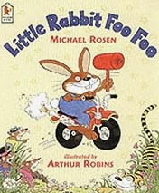  Little Rabbit Foo Foo  By Michael Rosen | 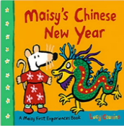  Maisy’s Chinese New  Year by Lucy Cousins | Everyones Welcome  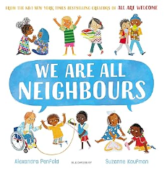  We are all Neighbours by Alexandra Penfold
Synopsis | Books in this series introduce emergent readers to the four seasons. In Winter, children are taken on a tour of things they can see in winter including typical winter activities and changes in the natural world. Beautiful photos, very simple repeated text, high frequency and decodable words and strong photo-to-text matching make this a perfect book for early readers to enjoy | It's snowing in Acorn Wood, and Squirrel wants to build a snowman. Will she and her friends find everything they need? Lift the flaps to find out in this wonderful wintry tale. | Timothy Pope has a brand new telescope and he's testing it out in the park. Peep through the die-cut holes in this book to see if you can spy a shark. Is that really a shark? Turn the page and find out | Follow and join in the family's excitement as they wade through the grass, splash through the river and squelch through the mud in search of a bear. What a surprise awaits them in the cave on the other side of the dark forest! | The bully-boy bunny likes nothing better than to ride through the forest bopping everyone on the head. Wriggly worms, tigers, no one is safe. But here comes the Good Fairy – and she is not amused! | Maisy is celebrating one of the world's biggest festivals: Chinese New Year! From hanging up lanterns to receiving lucky red packets and joining in the dragon dance at the parade, this bright and colourful storybook is a perfect introduction to the many joys of Chinese New Year. | Welcome to the neighbourhood where everyone is welcome. Where children of every culture play together, share food and laughter, and learn from each other’s traditions, where diversity is a strength.
Additional texts | 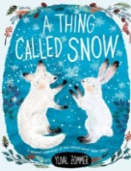 | 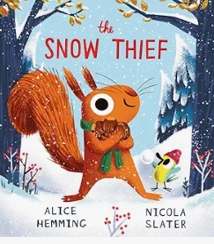 | 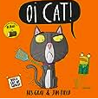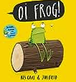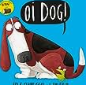 | 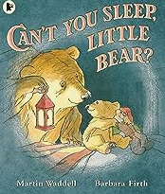 | 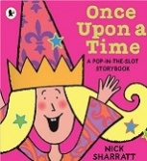 | 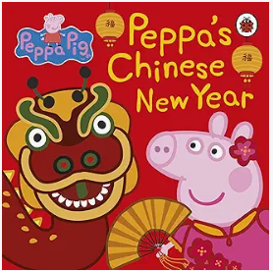  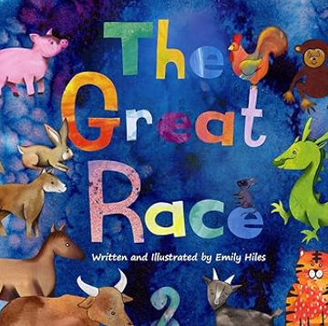
Themes/Outcomes | Changing seasons  Observing weather  Looking at ice | Exploring ice | Rhyming patterns / phonics | Repeated refrains and joining with stories.  Sensory stories | Repeated refrains and joining with stories. | UTW/ RE  Celebrations- Chinese New Year | Celebrating Differences  UTW/ RE  Celebrations celebrated in different families
Links |  |  |  | Year 1 Autumn Investigators topic. | Traditional tales in Y1
Topic/Term | Spring 2 – Spring/Growing/ Easter 4 weeks
Key Texts | Everyones welcome Text  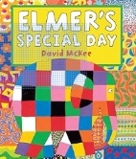  Elmer’s Special day by David Mc Kee | 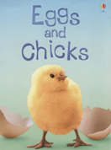  Eggs and Chicks by Fiona Patchett | Spring By Julia Donaldson  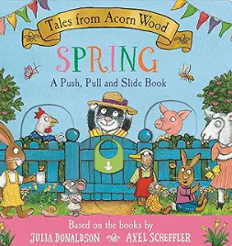 | 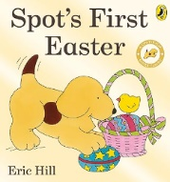  Spot’s first Easter By Eric Hill | 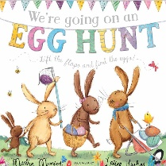  We’re going on a Egg Hunt by | 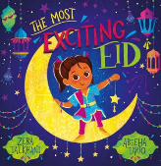  The most exciting Eid
Synopsis | It’s almost Elmer day again but with all the preparations and nosie they are upsettting the other animals. Elmer changes the rules and invites all of the animals to join the parade, but they have surprise in store for Elmer. | Which bird lays the biggest egg in the world and how do tiny chicks learn to fly? Beginner readers can find answers to these questions and more in this colourful information book. Illustrated with fabulous photos and artwork. Easy-to-read text specially written with the help of a reading expert. Internet links to carefully selected websites with pictures, information and activities | How are Rabbit, Cat, Hen and Pig celebrating Spring? Pull the tabs and open the flaps to find out…… | It’s Easter, and the Easter bunny has hidden some eggs for Spot to find! There’s lots of fun (and chocolate) to be had for Spot and all his friends as they join the hunt. | Join the bunnies on a lift the flap Easter story. | Safa is so excited for Eid-al-Fitr.She loves draing henna patterns on her hands, decorating her home and munching on biryani, kebabs and samosas. It is the perfect day. Then the best part comes: she gets to open her presents! She is gifted a shiny pink bicyle. The only thing is she absolutely doesn’t want to share with her cousin Alissa. As her mum takes her on a adventureto gift delicious Eid treats to their neighbours, Safa will realise how wonderful it is to make others happy!
Additional Texts | 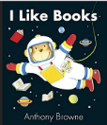  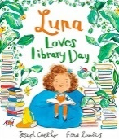 | 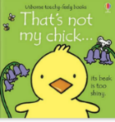  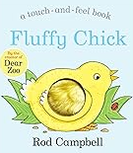  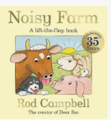  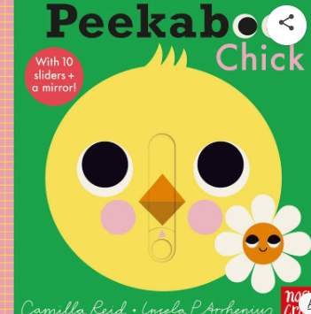 | 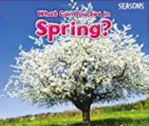 | 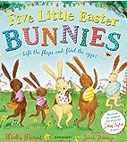  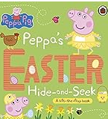 | 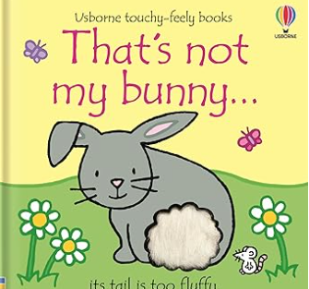
Themes/Outcomes | Friendship  Celebrations | Growing and changes.  Lifecycles  Happy Egg company: eggs in preschool- incubation | Growing seeds  Changes to a seed  Weather changes  What are the features of Spring? | Easter: RE | Changes to weather and seasons  Family Easter egg hunt in pre-school | Eid  Celebrations
Links |  | Foundation Stage – Farm Animals  FS - Life cycles: Minibeasts Topic Summer 2  Year 1: lifecycles  FS: lifecycle of caterpillar and butterflies. | Changes to seasons in FS and Y1. | Links to FS: Easter  RE – Christian beliefs – Year 1 | Year 1 – Materials/plants Science  Whole School – Internet Safety
Topic/Term | Summer 1 – Superheroes (People Who Help Us) 8 weeks
Key Texts/  Planning sequences | 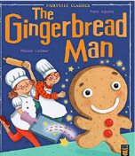  The Gingerbread Man By Mara Alperin |  | 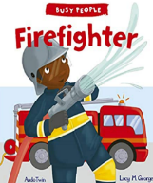  Firefighter by Lucy M George |  | 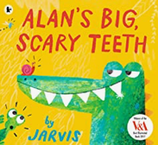  Alan’s Big Scary Teeth by Jarvis. |  | 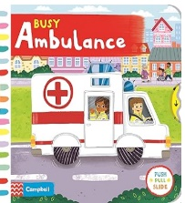  By Campbell books |  | 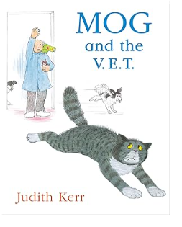  By Judith Kerr. |  | Everyone’s Welcome text  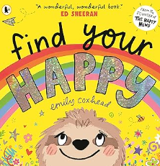
Synopsis | The cheeky little gingerbread man is having so much fun! He scurries away from Mr and Mrs Baker and all the hungry animals, but the he meets a crafty fox…Will the Gingerbread man meet a sticky end? |  | Step inside the life of Frank the Fighter and discover the challenges he faces in his very busy job! Follow him and his crew from the moment the fire station alarm bell rings to his arrival at the emergency. |  | Meet Alan the alligator, famed for his big, scary teeth. He sneaks into the jungle every day to scare the jungle animals ... But after a long day of scaring, Alan likes nothing better than to run a warm mud bath and take out his false teeth, which nobody knows about until his teeth go missing. What will Alan do now? |  | The Busy ambulance is on it’s way to an accident and then has to race to the hospital with flashing lights and a noisy siren. |  | Mog the cat is playing outside and hurts her paw. She will have to visit the vets, a place she does not like. Watch how she creates havoc when she is there. |  | Feeling happy is a wonderful thing! But do you ever feel sad or angry, frightened or shy? Everyone does sometimes, but with a little help with sloth and the people you love , there is always a way to FIND YOUR HAPPY!
Supporting Texts | 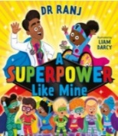  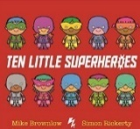  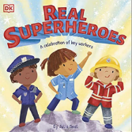 |  | 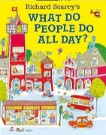  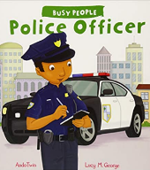 |  | 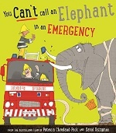  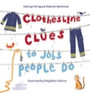 |  |   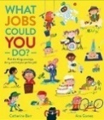 |  | 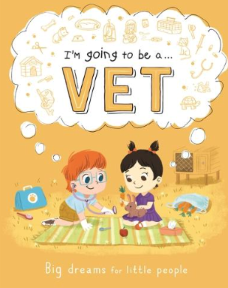
Themes | Sensory stories  Repeated refrains and joining with stories.  Baking |  | People who help us  A visit from the fire service |  | People who help us  Different types of occupations Science: Teeth  A visit from the dentist |  | People who help us  Looking at own family and their jobs |  | People who help us  Pets |  | Feelings  Sharing interests and hobbies
Links |  |  | Year 2 – fire and Light: Great fire of London (D.T- Fire engines) Year 1 and Year 5 Fire Service visit links. |  |  |  |  |  | Foundation Stage: farm animals
Topic/Term |  | Summer – By the Seaside/Transitions to school 5 weeks
Key Texts |  | 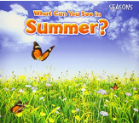  What Can You See in Summer? By Sian Smith |  | 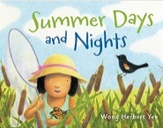  Summer days by Wong Herbert Yee |  | 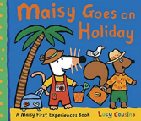  Maisie goes on Holiday by Lucy Cousins |  | 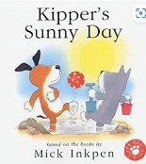  Kipper’s sunny day by Mick Inkpen |  | 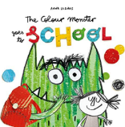  The Colour Monster goes to School by Anna Llenas | Everyone’s Welcome Text  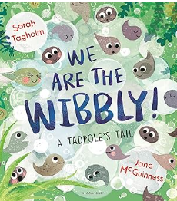
Synopsis |  | Books in this series introduce emergent readers to the four seasons. In Summer, children are taken on a tour of things they can see in summer including typical summer activities and changes in the natural world. Beautiful photos, very simple repeated text, high frequency and decodeable words and strong photo-to-text matching make this a perfect book for early readers to enjoy. |  | On a hot summer day, a little girl finds ways to entertain herself and stay cool. She catches a butterfly, sips lemonade, jumps in a pool, and goes on a picnic. At night, she sees an owl in a tree and a frog in a pond, and hears leaves rustling. Before long, she's fast asleep, dreaming about more summer days and summer nights. |  | In Maisy Goes on Holiday, Maisy enjoys packing her suitcase, meeting Cyril at a busy station and catching a train to the seaside. They have lots of fun on the beach and at the café, write postcards to their friends and finally sleep a peaceful night at their hotel (after bouncing on the beds, of course). Each of the First Experiences series describes a common first experience within Maisy's familiar and comforting world, offering a reassuring picture of something that might be new or less familiar. |  | Kipper loves sunny days, lift the flaps and find out what he does in the sun. |  | Follow The Colour Monster on a brand-new adventure, as he navigates his way through his first day at school! Anna Llenas's popular Colour Monster is back, and this time he's heading off to school! But what exactly is school? A spooky castle filled with terrifying animals? A place in the sky, amongst the rainbows and clouds? From music lessons, to lunchtime, to making new friends, the Colour Monster's first day of school is filled with exciting new adventures. | Doesn’t life move fast? One moment you’re in the wibbly, relaxing with your wibbly friends. The next they’ve all grown tails and turned into tadpoles! And what’s more, they are bursting OUT of the wibbly and you’ve got to keep Up!
Supporting Texts |  |  |  |  |  | 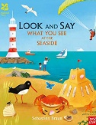  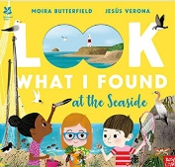 |  | 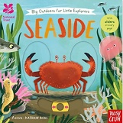  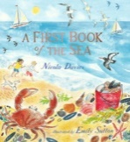 |  | 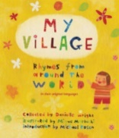
Themes |  | Season changes  Weather  Sun safety |  | Holiday, travel.  Season changes  Ice experiments/ melting ice |  | Weather  The beach  Animals at the beach/under the sea |  | Sun safety  The beach  Animals at the beach/under the sea |  | Transition to school  New starts  Meeting new teachers/ new children | Changes in life.  Growing up
Links |  | Year 1 – science: Seasons |  |  |  | Foundation Stage: Under the sea. |  | Foundation Stage: Under the sea. |  | Start of Pre-school  Starting Reception – New Beginnings  PSHE

